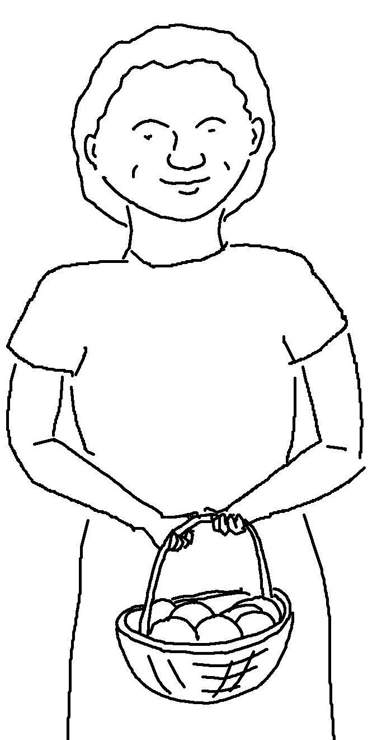

_ _ _ _, and you will _ _ _ _ _ _ _.
Your gift will return to you in full…
Matthew 8:27_{NLT}

